# Project

* Site-21-Api-Ng-Publishing-PostGres-Docker-Fallback
  + Copied from: Site-20-Api-Ng-PhotoManagement
* For the “MySocialConnect-SPA” issue npm install command to install all packages
  + ng serve : to run the spa

# New & Updates

|  |  |
| --- | --- |
| New | Updates |
|  | angular.json |
|  | /core/interceptors/loading.interceptor.ts |
|  | /core/services/signalr/message-hub.service.ts |
|  |  |
|  |  |
|  |  |
|  |  |
|  |  |
|  |  |
|  |  |

# Clear Database

If you want to clear database then drop it and recreate it

dotnet ef database drop

dotnet ef database update

# Important – Follow WebApi Doc

Follow WebApi document to setup deployment.

Any angular steps do per instructions from this doc

[020 Project21 -WebApi-Publishing-PostGres-Docker-Fallback.docx](020%20Project21%20-WebApi-Publishing-PostGres-Docker-Fallback.docx)

# Serve Angular From Api

The spa code will get published inside the MSC.WebApi, in a folder named wwwroot

## angular.json

outputPath property updated

|  |  |
| --- | --- |
| From | To |
| "architect": {          "build": {            "builder": "@angular-devkit/build-angular:browser",            "options": {              "outputPath": "dist/my-social-connect-spa",              "index": "src/index.html",              "main": "src/main.ts",              "polyfills": [                "zone.js"              ], | "architect": {          "build": {            "builder": "@angular-devkit/build-angular:browser",            "options": {              "outputPath": "../MySocialConnect-API/MSC.WebApi/wwwroot",              "index": "src/index.html",              "main": "src/main.ts",              "polyfills": [                "zone.js"              ], |

Change budgets as well

|  |  |
| --- | --- |
| From | To |
| "production": {                "budgets": [                  {                    "type": "initial",                    "maximumWarning": "500kb",                    "maximumError": "1mb"                  },                  {                    "type": "anyComponentStyle",                    "maximumWarning": "2kb",                    "maximumError": "4kb"                  }                ], | "production": {                "budgets": [                  {                    "type": "initial",                    "maximumWarning": "1mb",                    "maximumError": "2mb"                  },                  {                    "type": "anyComponentStyle",                    "maximumWarning": "2kb",                    "maximumError": "4kb"                  }                ], |

# Remove Fake Delay

## /core/interceptors/loading.interceptor.js

Update to only have the fake delay in dev mode and not in prod mode

    //return next.handle(request);

    return next.handle(request).pipe(

      //delay(this.helperService.LoadingSpinnerDelayMiliSec),

      //first item null cannot be used, use "identity" from rxjs

      (this.helperService.IsProduction ? identity : delay(this.helperService.LoadingSpinnerDelayMiliSec)),

      finalize(() => {

        if(isSpinnerAllowed)

          this.spinnerBusyService.idle();

      })

    );

# Fixing Messages

## /core/services/signalr/message-hub.service.ts

Our busy interceptor is show the spinner for the http.

For the signalR we need to do the same on CreateHubConnections

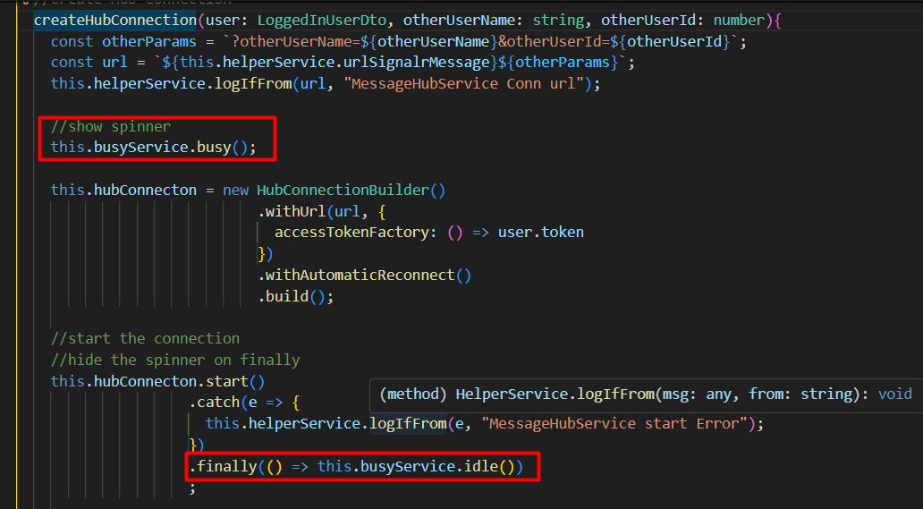

## /site/members/member-messages

### member-messages.component.html

fix the scrolling by moving the scrolling to the card-body

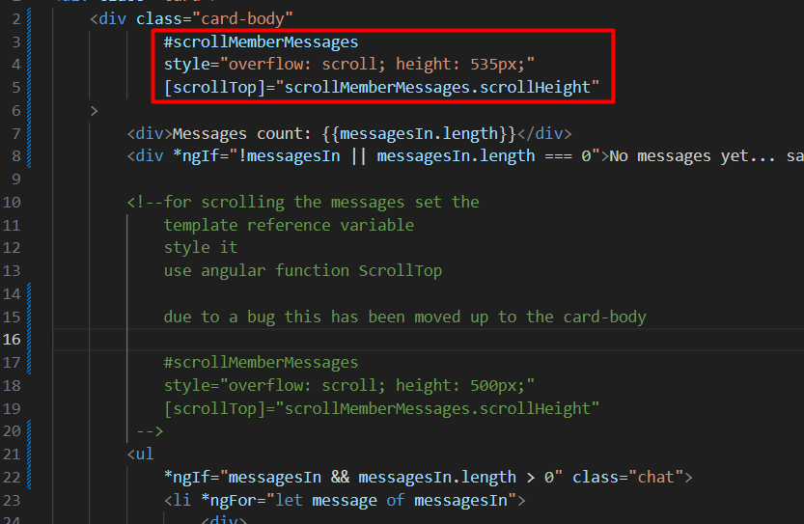

And also disable the Send button while the message is being sent



### member-messages.component.ts

set a var for isLoading

 isLoading = false;

and the update the submit message method

  OnSubmitMessageUsingHub(){

    if(!this.memberIn || !this.memberIn.id){

      this.toastr.error('User error', 'Error');

      return;

    }

    this.isLoading = true;

    //this is returning a promise

    //The newly added message will show via loadMessagesFromMessageHub

    this.messageHubService.createMessage(this.memberIn.id, this.messageContent)

                          .then(() => {

                            this.msgForm.reset();

                          })

                          .finally(() => this.isLoading = false )

                          ;

  }

# Production Build

## Build

Issue command

> ng build

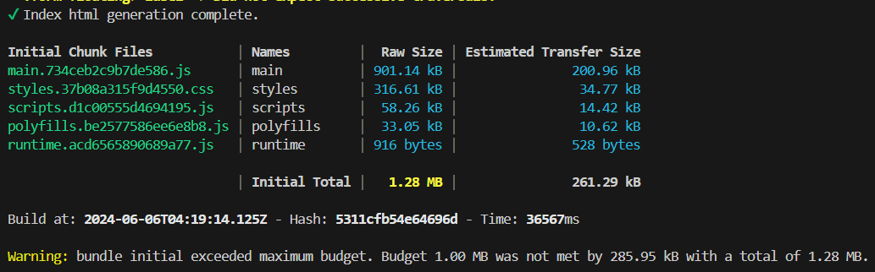

And the files pushed to wwwroot folder

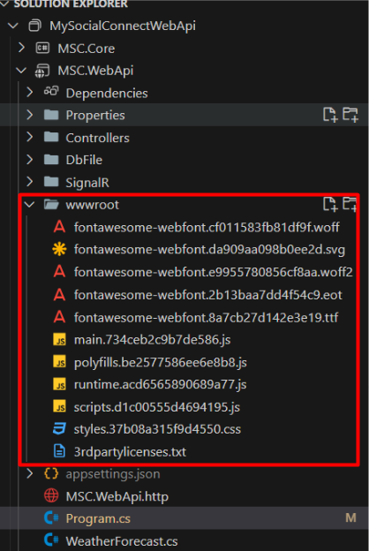

## Build Warning

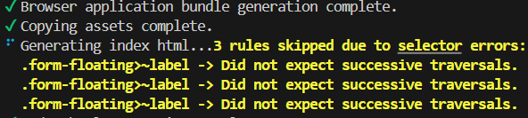

Add optimizations to the angular.json for production

              "optimization": {

                "scripts": true,

                "styles": {

                  "minify": true,

                  "inlineCritical": false

                },

                "fonts": true

              }

Full thing

          "configurations": {

            "production": {

              "budgets": [

                {

                  "type": "initial",

                  "maximumWarning": "1mb",

                  "maximumError": "2mb"

                },

                {

                  "type": "anyComponentStyle",

                  "maximumWarning": "2kb",

                  "maximumError": "4kb"

                }

              ],

              "fileReplacements": [

                {

                  "replace": "src/environments/environment.development.ts",

                  "with": "src/environments/environment.ts"

                }

              ],

              "outputHashing": "all",

              "optimization": {

                "scripts": true,

                "styles": {

                  "minify": true,

                  "inlineCritical": false

                },

                "fonts": true

              }

            },